Introduction
The CHNA Planning and Development Tool Kit provides an overview of the CHNA Planning and Development Committee’s guiding principles, examples of their application to proposed developments, along with key resources and links to assist you in the planning and development processes in Ottawa.
To navigate throughout this tool kit, you may click on the Content hyperlinked headings below to go directly to the section of interest. As well, you may click on any hyperlinked headings within this document, that will bring you back to this Content page.
Content
- CHNA Planning and Development Committee’s Guiding Principles
- Applying Guiding Principles to Proposed Developments with Examples
- City of Ottawa New Official Plan
- City of Ottawa Zoning By-law Review
- Intensification Plans
- Current Plans Impacting our Neighbourhood
- City of Ottawa Planning and Development Process
- Interesting Planning and Development Measures
- Key Links to Resources
- ANNEX A: Near Future and Ongoing Focus: Four Different Developments Impacting Our Community, including chart overview of CHNA ACTIONS with Three Different Developments
- ANNEX B: Impact of Surrounding Developments on Preston Street and Carling Avenue
To provide feedback and suggest further resources for this document, please send an email to: info@chnaottawa.ca And, to learn more about latest happenings checkout Civic Hospital Neighbourhood Association (CHNA) website.

A. CHNA Planning and Development Committee’s Guiding Principles
CHNA Planning and Development Committee operates on the basis of the following principles:
- Enhancing – Protecting – Preserving our Neighbourhood - Urban neighbourhoods, such as the Civic Hospital neighbourhood, are the heart of the City of Ottawa and should be enhanced, protected and preserved.

- Responsible Development within CHNA Boundaries - Development within CHNA boundaries is good for the community, however, they need to be sensitive to the heritage and design values of the existing neighbourhood and respectful of current residents.

- Resident-Centred Approaches to Decision Making on Planning and Development - Healthy neighbourhoods are, by their nature, resident-centred, therefore planning and development decisions must include bottom-up planning and meaningful consultations with current residents.

- Inclusive Neighbourhood - Neighbourhoods function best when they include a wide range of housing, income levels, demographics, local businesses, local services, sustainable ecosystems, safe streets, appealing public spaces and accessible meeting spaces for the community to come together.
B. Applying Guiding Principles to Proposed Developments with Examples
Each step we take matters – Even if it’s not an immediate win, the presence we provide and the actions we take to ensure responsible development for our residents, make a difference.

Formation of Subcommittees for Strategic Developments
In the past year, the CHNA Planning and Development Committee has expanded with the formation of a new sub-committee, the 1081 Carling Avenue Subcommittee. This subcommittee addresses the two high rises (initially 22 and 28 storeys), proposed by Taggart Realty Management for this site. It also serves as a case study in this approach to key developments, as residents have donated resources and fundraised to hire a lawyer and professional planners to support the CHNA’s response on the proposal. Going forward, other projects of concern in our neighbourhood could require similar support
Collaborations
In addition to our support of the 1081 Carling Avenue Subcommittee, the CHNA Planning and Development Committee collaborates with City Planners and Staff, City Councillors, developers, architects, and the Federation of Citizen Associations and other stakeholders, to aid in responsible intensification in our community.
Committee of Adjustment (CoA)– Member Support
We help provide guidance to CHNA members opposing minor variance applications to be heard by the City of Ottawa Committee of Adjustment process.
CoA Example: Variance requests for attached and integrated garages
CHNA supports new builds, and at the same time, we work hard to protect our mature neighbourhood’s streetscape character by supporting bylaws put in place to do just that.
Our neighbourhood faces increased pressure from developers wanting to buy homes in our area on larger lots to subdivide the property, remove the existing home and redevelop the property by building two homes. Unfortunately, the designs often are car centric and feature front facing attached garages which are typically not the dominant character in our mature neighbourhood. The city has put into place a bylaw that prohibits these garages unless they are consistent with the existing streetscape character on the street. It is up to the City’s Committee of Adjustment to approve or reject applications for bylaw variance requests asking to build an integrated garage. We have actively participated in Committee of Adjustment applications to support the bylaw.
Be aware that even when the Committee of Adjustment supports this bylaw and turns down a proposal for an attached and integrated garage, it’s possible this decision could later be overturned upon appeal to the Ontario Land Tribunal (more detail can be found in section G. City of Ottawa Planning and Development Process).

Near Future and Ongoing Focus: Three Different Developments Impacting Our Community (*For more detailed overview of these projects, please refer to ANNEX A )
- New Civic Hospital Campus – 930 Carling Avenue/520 Preston Street - $2.8 billion development to be ready by 2028, with first structure already approved by The City - Above ground four storey Parkade
  - Civic Hospital Relocation - Civic Hospital Neighbourhood Association (chnaottawa.ca)
  - Preston Street and Carling Avenue Secondary Plan
- 1081 Carling Avenue - Proposal of two towers of 22 and 28 storeys
  - 1081 Carling Sub-Committee - Civic Hospital Neighbourhood Association (chnaottawa.ca)
- 30 Railway Street - Proposal of three storey, eight-unit low rise apartment dwelling
  - Planning and Development - Civic Hospital Neighbourhood Association (chnaottawa.ca)
C. City of Ottawa New Official Plan
The City of Ottawa’s New Official Plan was approved in November 2022, and outlines how the City will make Ottawa the most livable mid-sized city in North America over the next 25 years. It outlines in a broad manner the land use and development guidelines within Ottawa. Section 11 – Implementation of City of Ottawa Official Plan- outlines tools used to implement policies and is helpful for us to refer to, as we consult in the ongoing Comprehensive Zoning By-law process: https://documents.ottawa.ca/sites/documents/files/section11_op_en.pdf
The City’s goals, objectives and policies in the New Official Plan are intended to manage and direct physical change under 5 categories or “The 5 Big Moves”:
- Growth Management
- Mobility
- Urban and Community Design
- Climate, Energy Evolution and Public Health
- Economic Development
Related City Master Plans
- Infrastructure Master Plan
- Transportation Master Plan
- Urban Forest and Greenspace Master Plan
- Climate Change Master Plan
- 10 Year Housing and Homelessness Plan
- Parks and Recreation Facilities Master Plan

D. Zoning By-law Review
The city is about to start an intense review of the zoning bylaws to bring them in line with the new Official Plan. Zoning bylaws outlines how a specific parcel of land may be used. Zoning By-laws regulate lot size, parking requirements, building height and other site-specific factors.
Following is an Overview of Zoning Items to be Reviewed and Updated- 2022-2024
- Residential Form-based Zones
- Residential Provisions and Zoning Map
- Categorical Land Use Approach and Definitions
- Zone Structure and Organization
- Administration
- General Provisions
- Industrial Zones
- Mixed-Use/Commercial Zones
- Hubs and Corridors Zones
- Transit-Oriented Zones
- Environmental Zones
- Rural Zones
- Specific Use Provisions
- Heritage Designations and Overlays
- Exceptions and Schedules
- Institutional Zones
- Open Space Zones
- Rural Village Zones
- Special Use Districts
- Economic Districts
- Mobility and Parking
- New/Emerging Issues

*The following features information on New Zoning By-law Discussion Papers and Surveys, released on March 6, 2023 for Public Consultation. Approval by Ottawa City Council expected in 2025.

New Zoning By-law (Information provided by the City of Ottawa)
The City of Ottawa is developing a new comprehensive Zoning By-law for approval by Council in 2025. The by-law will implement the policies and directions in the new Official Plan approved by the Minister of Municipal Affairs and Housing on November 04, 2022. Once approved, the new Zoning By-law will replace the current Zoning By-law (By-law 2008-250).
Starting in 2023, the City will be consulting with communities, the development industry, grass-roots organizations, non-profits and other stakeholders to ensure that everyone gets a chance to have their say in the new Zoning By-law.
The Engage Ottawa page will be your one-stop shop for project updates and information on future public engagement opportunities. You will also find FAQ’s, blogs and future drafts of the by-law as they become available.
To sign up for news and updates on this important project, please email newzoning@ottawa.ca .
Honouring Statement
Ottawa is built on unceded Anishinabe Algonquin territory. The peoples of the Anishinabe Algonquin Nation have lived on this territory for millennia. Their culture and presence have nurtured and continue to nurture this land. The City of Ottawa honours the peoples and land of the Anishinabe Algonquin Nation. The City of Ottawa honours all First Nations, Inuit and Métis peoples, and their valuable past and present contributions to this land.
- Changes from Bill 23
Bill 23, More Homes Built Faster Act, 2022, received Royal Assent on November 28, 2022. The Bill made changes to the Planning Act and other provincial acts. Changes to the Planning Actinclude overriding municipal zoning by-laws to allow up to three “gentle intensification” principal units on any urban-serviced residential parcel, including in a detached, semi-detached or townhouse and prohibiting a zoning by-law from restricting such from occurring. Residents will find the most up-to-date information on Bill 23 on this webpage.
- New Zoning By-law Discussion Papers and Surveys
Consultation on developing a new Zoning By-law is now open with the release of seven Discussion Papers and corresponding surveys. These papers address key issues relating to the implementation of the new Official Plan, including:
  - Climate Change, Resiliency, Public Health
    - Climate Change, Resiliency, Public Health Discussion Paper
    - Climate Change, Resiliency, Public Health One Pager
    - Climate Change, Resiliency, Public Health Survey
  - Equity, Diversity and Inclusion
    - Equity, Diversity and Inclusion Discussion Paper
    - Equity, Diversity and Inclusion One Pager
    - Equity, Diversity and Inclusion Survey
  - How Zoning Can Regulate Trees
    - How Zoning Can Regulate Trees Discussion Paper
    - How Zoning Can Regulate Trees One Pager
    - How Zoning Can Regulate Trees Survey
  - Land Use Strategies for the New Zoning By-law
    - Land Use Strategies for the New Zoning By-law Discussion Paper
    - Land Use Strategies for the New Zoning By-law One Pager
    - Land Use Strategies for the New Zoning By-law Survey
  - Neighbourhood Character
    - Neighbourhood Character Discussion Paper
    - Neighbourhood Character One Pager
    - Neighbourhood Character Survey
  - Neighbourhood Zones
    - Neighbourhood Zones Discussion Paper
    - Neighbourhood Zones One Pager
    - Neighbourhood Zones Survey
  - Rural Zoning Issues
    - Rural Zoning Issues Discussion Paper
    - Rural Zoning Issues One Pager
    - Rural Zoning Issues Survey
The release of these discussion papers is the first chance for the public to consult on the implementation of the recently approved new Official plan through the development of a new Ottawa Zoning By-law. The City welcomes feedback and input from members of the public and will summarize the received responses in an "As We Heard It" report later this year. Consultations on the discussion papers will inform the development of the first draft of the new Zoning By-law. We encourage members of the public to review the discussion papers and share their thoughts and ideas, as their input will play a critical role in shaping the future of our city.

E. Intensification Plans
Redevelopment at higher densities—or, intensification—is targeted for:
- Traditional mainstreets in Central Ottawa such as Wellington, Bank, McArthur, and Beechwood Arterial mainstreets such as portions of Carling Avenue, St. Laurent Boulevard and Montreal Road.
- Near key rapid transit stations in Central Ottawa such as Tunney’s Pasture, Billings Bridge and Preston Street.
- The goal is to create a convenient mix of uses and attractive public areas where walking and cycling support transit use and achievement of city-wide targets for sustainable transportation.
- Outside the areas targeted for intensification, infill and redevelopment that is compatible with the surrounding neighbourhood is supported. A Mature Neighbourhoods Overlay in the Zoning By-law was approved in 2015 to regulate low-rise residential development throughout Central Ottawa so that it complements and reinforces the established neighbourhood character as seen along each street.
F. Current Plans Impacting our Neighbourhood
Recently-completed or ongoing plans that have an impact on Civic Hospital Neighbourhood include:
- The City is amending its Official Plan and Zoning By-law to reflect updated flood plain mapping prepared by the Conservation Authorities. Affected areas in Central Ottawa include the Ottawa River shoreline.
- The development of a new Trillium Line O-Train station at Gladstone Avenue, connecting area residents to Bayview station in the north to Bowesville in the south.
- High Rise Urban Design This research-based study will update the current Urban Design Guidelines for High-Rise Housing and develop new zoning provisions for high-rise buildings. The study will address how high-rise buildings should be designed in locations where they are currently permitted by Council-approved policies and regulations like the Official Plan, Secondary Plans, Zoning By-law, and Community Design Plans.
- Ottawa Hospital On December 2, 2016, the Minister of Canadian Heritage approved 930 Carling Avenue and 520 Preston Street, commonly referred to as the Sir John Carling site, as the location for the new Civic Hospital Campus.

- Scott Street Renewal The City of Ottawa has initiated a functional design study for the modification of cycling facilities and eastbound travel lanes on Scott and Albert Streets between Smirle Avenue and City Centre Avenue. These changes are being considered after the removal of the temporary busway along this corridor, which will not be required after the Confederation Line of the Light Rail Transit (LRT) is fully in service. This study examines the section between Smirle Avenue (near Tunney’s Pasture Station) and City Centre Avenue (near Bayview Station).
- Creative Venues Zoning By-law Amendment – In 2012, Council approved the Renewed Action Plan for Arts, Heritage and Culture (2013-2018). One of the key strategies is to "preserve and develop cultural and creative places and spaces." To that end, the Planning, Infrastructure and Economic Development Department has undertaken a review of the Zoning By-law to ensure that there are no undue obstacles to establishing and operating live music and performance venues in appropriate locations.
- Small Scale Industrial This proposal introduces new zoning provisions allowing limited, small-scale manufacturing and food processing, including micro-distilleries and micro-breweries, in commercial areas. An earlier proposal was circulated to the public and to technical agencies in February 2017. The proposed amendment is intended to allow small-scale light manufacturing under certain circumstances in commercial and mixed-use areas.
- Heritage Inventory Project On Wednesday, March 23, 2016, City Council passed by-law 2016-089 to adopt the Rockcliffe Park Heritage Conservation District Plan. The new Plan replaces the current guidelines approved by the former Village of Rockcliffe Park in 1997.
- Various Area Traffic Management measures will be implemented in Centretown, on Bayswater Avenue, on Crichton Street, on Riverdale Avenue and Sunnyside Avenue
- Carling Transit Priority Measures Study, Lincoln Fields to Bronson Avenue
G. City of Ottawa Planning and Development Process
These documents will provide an insight into the City of Ottawa Planning and Development Process.

Primer 1 [ PDF 1.182 MB ] – Planning Primer I – The Legislative Background for Planning in Ontario walks you through Province of Ontario Planning Act, City of Ottawa Official Plan and Zoning, Ontario Municipal Board, Legislation Affecting Planning in Ontario, Standing Committees of Council, Council’s Advisory Committees and Bill 73 – Proposed Smart Growth for our Communities Act (2015).

Primer II [ PDF 1.762 MB ] – Planning Primer II – Development Review covers Common Planning Acronyms, Development Applications, Application Review Process, The Committee of Adjustment Process, Pre-Application Consultation, Urban Design Review Panel and Summary of Development Applications.

More slide presentations on courses offered:
Development Charges Elective [ PDF 640 KB ]
Park Planning Elective [ PDF 5.807 MB ]
Residential Intensification and Infill Elective [ PDF 6.083 KB ]
Heritage Planning Elective [ PDF 3.550 MB ]
Secondary Planning Processes Elective [ PDF 9.959 MB ]
Natural Systems Elective [ 4.923 MB ]
Planning for Healthy Communities Elective [ PDF 3.198 MB ]

Mature Neighbourhood Streetscape Character By-law
Streetscape Character Analysis (SCA) Manual

Committee of Adjustment
Guides:
- Committee of Adjustment & Local Planning Appeal Tribunal: A Guide To Objecting - Glebe Community Association (2021): https://glebeca.ca/wp-content/uploads/2021/03/Guide-for-Objecting-to-a-Minor-Variance.pdf
- Canadian Environmental Law Association’s two pager explaining what third-party appeal remain after passage of Ontario’s Bill 23 – More Homes Built Faster Act (2022).

How the Committee of Adjustment (COA) and Ontario Land Tribunal (OLT) evaluate a variance request.
Requests are evaluated against the “Four Tests” under s. 45(1) Planning Act and Provincial Policy Statement
These tests are:
- Does the proposed variance maintain the general purpose and intent of the City’s Official Plan?
- Does it maintain the general purpose and intent of the Zoning By-law?
- Is it desirable for the appropriate use of the subject property?
- Is it minor?
The proposed variance must also be consistent with the Provincial Policy Statement, 2020 (“PPS”), that covers policies about managing growth, using and managing natural resources, protecting the environment, and public health and safety. When making its decision, the Tribunal must have regard to the matters of provincial interest set out in s.2 of the Planning Act and it must have regard to the decision of the Committee of Adjustment and the information considered by it, as required under s.2.1(1) of the Planning Act.
Tribunal’s Analysis and Findings – Why would the OLT overturn a Committee of Adjustment decision? For example, a zoning Bylaw was established to ensure compatible development in mature neighbourhoods and does not allow the building of front facing attached garages if they are not in keeping with the streetscape character of the area. How has the Tribunal interpreted and assessed some of these proposals? They have allowed the variance based on the following reasoning:
- Tribunal finds that the proposed variance would not change the dominant character of the street and the proposed garage would not unduly alter the streetscape.
- Tribunal finds that the proposed garage would be secondary in nature to the existing dwelling and would be similar in appearance to other garages on the street.
- It finds that although the proposed development would not be exactly the same as the prevalent detached form of garage in the immediate vicinity of the subject property, given the frontage of the subject property, and the proposed height, size, and location of the proposed garage, the proposed garage would be very similar to others in the area and it would be in keeping with the character of the area.
- It finds that the proposed variance will not facilitate a development resulting in a vehicle-dominated frontage, impact the principal entrance way to the dwelling, or impact the view of it from the street.

For your information, here is a link to search for properties in Ontario Land Tribunals Decisions-Orders: https://olt.gov.on.ca/tribunals/ert/decisions-orders/

H. Interesting Planning and Development Measures
Minister’s Zoning Orders (MZOs) overrides lands/buildings with heritage designations.
The Planning Act gives the Minister of Municipal Affairs and Housing the authority to control the use of any land in the province. Zoning orders can be used to protect a provincial interest or to help overcome potential barriers or delays to critical projects. If there is a conflict between a minister’s zoning order and a municipal bylaw, the minister’s zoning order prevails.
Ontario using frequent Minister’s Zoning Orders to fast-track development: auditor general | Globalnews.ca https://globalnews.ca/news/8416315/ontario-ministers-zoning-orders-auditor-general/
Inclusionary Zoning
Inclusionary Zoning is a tool that municipalities may use to address their community’s affordable housing needs by requiring that new housing developments of 10 units or more need to include affordable housing units. Inclusionary Zoning can only be used in protected major transit station areas (lands around stations/stops for rail, subway and certain other forms of transit that are protected by official plan policies), areas where the community planning permit system is required or as set out by the minister. When official plan policies related to inclusionary zoning and zoning bylaws are in place, municipalities can require affordable housing units to be included in residential developments. These units would need to be maintained as affordable over a period of time specified by the municipality.
Interim Control By-law (Interesting tool to request freezing further work on proposed development)
Section 38 of the Planning Act allows municipalities to pass an Interim Control By-law which puts a temporary freeze on some land uses while a municipality is studying or reviewing its policies. The Interim Control By-law can be imposed for only a year, with a maximum extension of another year.
Also, there is no ability to appeal an interim control bylaw when it is first passed, however, an extension to a bylaw may be appealed. The Planning Act provides that an interim control bylaw remains in effect past the two-year period if the new zoning bylaw which replaces the interim control bylaw is appealed to the Ontario Land Tribunal (OLT).
City of Ottawa Official Plan (OP) Section 11 – Implementation of City of Ottawa Official Plan outlines tools used to implement policies and is helpful for us to refer to, as we consult in the Comprehensive Zoning By-law process: https://documents.ottawa.ca/sites/documents/files/section11_op_en.pdf
City of Ottawa Official Plan - High Performance Development Standard Using the authority set out under the Planning Act, the City proposes to advance sustainable and resilient design priorities by phasing in minimum performance measures for new development that require site plan and plan of subdivision approval, starting in summer 2022. This includes Draft Terms of Reference for the Community Energy Plan and Energy Model Report – finals to be brought forward with the package of Terms of Reference with the Official Plan Implementation Report. The Planning Committee will consider the High Performance Development Standard final report on March 10, 2022. The Agriculture and Rural Affairs Committee will consider the final report on April 7, 2022. Council will consider the final report on April 13, 2022.
*Note: Because The Ottawa Hospital New Civic Campus Site Plan Control was previously approved, New Civic Campus does not have to adhere to these new standards, nor does Claridge Tower on Preston Street and Carling Avenue, and most likely, 829 Carling Avenue (60 Storey Tower), nor any proposed development that will have their Site Plan Control approved before the High Performance Development Standards are enforced (anticipated to be enforced in 2023).
I. Key Links to Resources
The Ottawa Hospital New Civic Campus
https://www.cbc.ca/news/canada/ottawa/ottawa-civic-hospital-master-site-plan-1.6196384
https://newcivicdevelopment.ca/newsroom/the-ottawa-hospital-completes-next-stage-of-planning-for-new-civic-development/
New Campus Development For The Ottawa Hospital - Hospital and Central Utility Plant - Neighbourhood Traffic Management Strategy - Prepared by Parsons (December 2022)
Lots to consider in terms of extent/specifics/advanced planning already in place for current civic campus redevelopment, outlined at https://www.ottawahospital.on.ca/en/healthy-tomorrows/a-look-to-the-future-six-innovations-coming-to-our-campuses/
- Onsite long-term care homes at the Civic, run by Schlegel Villages https://schlegelvillages.com
- New Rehabilitation Centre at the Civic Campus
- No timeline for the current campus rebuild
Impact of Carling Avenue Rehabilitation Project
- New Civic Campus and Current Civic Campus plans for development/redevelopment, provide an opportunity to examine how Carling Avenue will be impacted. For instance, could the repurposed Civic Campus be entirely served from Carling Avenue?

- Impact of other builds (towers) on Carling Avenue – 1053 Carling Avenue reconstruction adds to the mitigation challenges arising from 1081 Carling Avenue expansion, and the yet to be determined proposals for 991 Carling Avenue.
Province of Ontario Planning Act

City of Ottawa Official Plan

Memos to Council
Feb 02, 2023 - Below are a series of memos provided to Ottawa City Council on the new Official Plan.
- Memo to Council – Official Plan Decision
- Memo to Council – Official Plan Modifications
  - Table 1 – Analysis of Ministerial Modifications to the Official Plan
The final version of the Official Plan is available on Ottawa.ca.

Zoning By-law Amendment
The Official Plan outlines in a broad manner the land use and development guidelines within Ottawa. A Zoning By-law, on the other hand, outlines how a specific parcel of land may be used. Zoning By-laws also regulate lot size, parking requirements, building height and other site-specific factors.
If a proponent wishes to develop a property in a manner that deviates from the current zoning provisions, they must apply for a Zoning By-law Amendment; also referred to as a rezoning. For example, a change of use from residential to commercial would require a Zoning By-law Amendment.
Sometimes a property owner only wants to make a minor deviation to a Zoning By-law provision such as a building setback or height restriction. Owners who want to differ only slightly from Zoning By-law provisions can alternatively apply to the Committee of Adjustment for what is known as a minor variance.
1. Before you begin
Before making an application, you should discuss your proposal with staff. Pre-application consultation with City staff is required for a Zoning By-law Amendment. The pre-application process is designed to help promote the exchange of information and development considerations early in the planning process and a customized list of the studies and plans required in support of a development application is provided. If you fail to consult with staff, the City cannot guarantee the completeness or accuracy of your application submission which may result in processing delays.
2. Process
An application for a Zoning By-law Amendment involves public consultation including providing notice to all property owners within 120 metres of the subject site. City Council must approve any amendment to the Zoning By-law, which is subject to an appeal process. The Planning Act has a provision whereby City Council must make a decision on any Zoning By-law Amendment application within 90 days of receiving a complete application. If City Council does not make a decision within this timeframe, the applicant can appeal to the Ontario Land Tribunal on the basis that a decision has not been made within this time period. For additional details on the steps associated with the processing and review of development applications, please refer to the City’s development application process information.
3. Fees
There are three types of Zoning By-law Amendments – a major rezoning, a minor rezoning and one that arises from the severance of a surplus farm dwelling. A minor rezoning only applies to the following:
- Modifications to performance regulations only (not adding a new use to the zone, but only requesting a change to regulations such as height, floor space index, density, yards etc.)
- Extension of a zoning boundary to reflect addition of lands to existing property
- Establishment of a group home (request that this use be permitted)
- Lifting of interim control for one use only
- Temporary rezoning
- Any zoning changes required as a condition of severance
- A change in use that is wholly contained within an existing buildings envelope, where no building permit has been issued within the previous two years to increase the size of the building and which is not located within a residential zone, as defined by Zoning By-law 2008-250, to introduce one new non-residential use. No additional amendments to performance standards may be sought and the change in use cannot result in the establishment of any of the following uses:
- Amusement centre or Amusement Park;
- Automobile body shop;
- Automobile dealership;
- Automobile rental establishment;
- Automobile service station;
- Heavy equipment and vehicle sales, rental and servicing;
- Drive-through facility;
- Bar;
- Kennel;
- Nightclub;
- Payday Loan Establishment
The following fees (effective January 1, 2022) apply to an application for Zoning By-law Amendment.
Major Zoning Amendment $22,472.80
Minor Zoning Amendment $11,907.80
- Plus an initial Conservation Authority fee
- Wards 7, 8, 9, 12, 13, 14, 15, 16, 17, 18 $120 or
- Remainder of City $400
Related to Severance of Surplus Farm Dwelling $4,969.77
The Conservation Authority will invoice for any additional fees and technical report review as required.
Please see additional information related to the City’s Development Application Fees including information related to reductions for multiple applications, on-site signs, re-circulations, Ontario Land Tribunal City Legal Costs as well as refunds.
4. Apply
Applications can be submitted to planningcirculations@ottawa.ca accompanied by required plans, studies and any other information that may be needed to assess your application.
- Note: If using a file sharing / transfer site to submit supporting documents, please select one that does not restrict access to a single planning staff member or email address.
Zoning By-law Amendment Application Form
Upon application submission, File Leads will provide confirmation of the amount due, the specific payment methods available for the application type, and the necessary details for the different payment methods.

Application commissioning, fees and payments
Client Service Centres will continue to offer commissioning services for applications and handle payments for new applications. Please ensure the payer’s name and address are indicated on the cheque.
To have an application form commissioned or to make a payment, please make an appointment in person at a Client Service Centre:
- City Hall, 110 Laurier Avenue West
- Ben Franklin Place, 101 Centrepointe Drive
- Kanata, 580 Terry Fox Drive
- Orleans, 255 Centrum Boulevard
- Metcalfe, 8243 Victoria Street
- West Carleton, 5670 Carp Road
- North Gower, 2155 Roger Stevens Drive
5. Contact
If you require assistance using an electronic application form please contact a City of Ottawa Development Information Officer, located at any of the Client Service Centres. You can make an appointment by calling 3-1-1 and asking to speak with a Development Information Officer.
If you would like to speak with planning staff please contact the appropriate development review Planner III by calling 3-1-1 and providing the address of the property you wish to discuss.

Official Plan and Master Plans

Official Plan
- New Official Plan

Climate Change Master Plan
- Climate Change Master Plan
- Climate Emergency

Greenspace Master Plan
- Strategies for Ottawa’s Urban Greenspaces
- Summary
- Section 1: A Greenspace Master Plan
- Section 2: Identifying Ottawa's Greenspaces and the Urban Greenspace Network
- Section 3: Achieving the Vision
- Section 4: Implementation
- Section 5: Appendices

Human Services Plan
Read about the City’s plan to increase access to services and facilities for Ottawa’s diverse communities and citizens.

Infrastructure Master Plan
The Infrastructure Master Plan is currently under review. Provide feedback on Engage Ottawa

A growth-focused plan for Ottawa’s water resource systems.
The purpose of the City of Ottawa's Infrastructure Master Plan (IMP) is to support the overall city-wide Official Plan (OP) goals of creating more vibrant, healthy and complete neighbourhoods across the municipality while ensuring long-term affordability for both the City government and residents.
Efficient management, responsible operation and judiciously targeted growth of water, wastewater, and stormwater infrastructure play a major role in the pursuit of these goals. The IMP supports the OP by ensuring there is enough infrastructure capacity in the right areas of the municipality at the right service levels at the right time to accommodate development and redevelopment until 2031 when the City of Ottawa population is expected to reach 1.14 million.
Chapters 1 to 4 [ PDF 1.5 MB
Chapter 5.1 to Section 5.3 [ PDF 6.7 MB
Chapter 5.4 to Section 5.6 [ PDF 7.6 MB
Chapter 6 to 9 [ PDF 206 KB
Annex A.1 [ PDF 221 KB
Annex A.2 [ PDF 4.1 MB
Annex A.2 Wastewater Project Sheet [ PDF 5 MB
Annex A.3 Schedules 1 to 4 [ PDF 4.2 MB
Annex A.3 Schedules 5 to 7 [ PDF 3.5 MB
Annexes B to D [ PDF 224 KB
If you have questions regarding the Infrastructure Master Plan, please contact:
Christopher Rogers
Program Manager
Infrastructure and Water Services
110 Laurier Ave West
Ottawa, ON K1P 1J1
Tel.: 613-580-2424, ext. 27785
Email: christopher.rogers@ottawa.ca

Land Evaluation and Area Review (LEAR)
The Province of Ontario requires municipalities to protect prime agricultural areas for long-term use for local agriculture. The purpose of a Land Evaluation and Area Review system, or LEAR, is to assist in the identification of these prime agricultural areas.
In 2011 Ottawa was home to 1,125 farm holdings, comprising 120,000 hectares of farmland dedicated to a mixture of cash crops, livestock operations and a growing number of local fresh food producers. These operations produced agricultural products with a value estimated at over $200 million.
In December 2016, the City of Ottawa adopted a new LEAR system to replace the system developed by the former Regional Municipality of Ottawa-Carleton in 1997. That system resulted in the identification of the agricultural areas designated as Agricultural Resource Areas as shown on Schedule A to the City’s Official Plan.

What is the LEAR system?
The primary component is the identification of land, comprised of soils, classed as 1, 2 and 3 in the Canada Land Inventory (CLI).
These soils provide the greatest flexibility to support a variety of crops. A LEAR system also uses other factors in addition to soil class in order to identify the best areas of ongoing agriculture. The results of the assessment of each rural property using the LEAR criteria are mapped and the prime agricultural areas are identified as areas of 250 ha or greater that are predominantly CLI classes 1-3 soils.

This new LEAR system updates a number of factors to respond to new soils mapping and reflects changes in the size and nature of farms over the last 20 years. The Ontario Municipal Board directed the City to complete this update as part of the comprehensive review of the Official Plan.

The LEAR report has two volumes:
LEAR Volume 1 [PDF 3.61 MB] contains a description of the new LEAR system and how properties are scored.
LEAR Volume 2 [PDF 7.59 MB] contains LEAR data for each scored property.
Anyone can use the LEAR map to search for their property and see the new LEAR scoring or download the printable map [PDF 5.77 MB].

How is the LEAR system used?
The new LEAR was used as part of the review of the Official Plan and will inform the assessment of applications in the Agricultural Resource Area designation, such as new renewable energy projects or new agriculture-related uses.
Changes proposed to the Agricultural Resource Area designation following the update of the LEAR system have been incorporated into the Official Plan.
Related links
Canada Land Inventory (CLI) soil capability for agriculture mapping
Official Plan Amendment #180

Further information
City of Ottawa
Planning, Infrastructure and Economic Development
110 Laurier Avenue West
Ottawa, ON K1P 1J1
613-580-2424
Email : planning@ottawa.ca(link opens email application)

Ottawa Cycling Plan
The Active Transportation Plan (formerly the Ottawa Cycling Plan) is currently being updated.
If you'd like more information please visit the project page.

The 2013 Ottawa Cycling Plan (OCP2013) is a long-term strategy to strengthen and support cycling in the city. It was developed as part of the Building a Liveable Ottawa process, which also led to updates of the City's Official Plan, Transportation Master Plan, Ottawa Pedestrian Plan and Infrastructure Master Plan.
The project and network maps that support the OCP2013 can be found in the on-line geoOttawa mapping tool, in the Layer List tool under Cycling and Cycling Plan. A complete description on how to use GeoOttawa can be found in Annex C of the cycling plan.
2013 Ottawa Cycling Plan [ PDF 21.3 MB ]

Ottawa Pedestrian Plan
The Active Transportation Plan (formerly the Ottawa Pedestrian Plan) is currently being updated.
If you'd like more information please visit the project page here.
The existing pedestrian network and the future Affordable Pedestrian Network projects approved in the Ottawa Pedestrian Plan (OPP) 2013 can be viewed in map format on-line at geoOttawa. Under the drop-down menu "More Layers" click on Pedestrian Plan to initiate. A complete list of the future Affordable Pedestrian Network projects can be found in Annex E of the Ottawa Pedestrian Plan.
2013 Ottawa Pedestrian Plan [ PDF 6.8 MB ]
Zlatko Krstulic
Senior Project Manager
Transportation Planning
Transportation Services Department
613-580-2424, ext. 21827
Email: zlatko.krstulic@ottawa.ca(link opens email application)

Ottawa Transition Board Final Report
The Ottawa Transition Board oversaw the amalgamation of the Region of Ottawa-Carleton and 11 municipalities to create the new City of Ottawa on January 1, 2001. The work of the board is summarized in its final report [PDF – 5.2 MB]. If you wish to receive this report in another format or any other public documents created by the board, please contact Claire Lee at 613-580-2424, ext. 13180 (TTY: 613-580-2401).

Transportation Master Plan
The Transportation Master Plan is currently being updated. If you'd like more information please visit the project page.

On November 26, 2013, the Ottawa City Council unanimously approved the Transportation Master Plan, Official Plan, Infrastructure Master Plan, Ottawa Cycling Plan and Ottawa Pedestrian Plan. Together, these five plans set the vision for Ottawa's future growth to 2031.
The Transportation Master Plan (TMP) identifies the transportation facilities, services and policies that the City of Ottawa will implement to serve a projected population of 1.14 million people by 2031. It sets direction for the City's day-to-day transportation programs and provides a basis for budget planning that is consistent with the growth management policies of the City's Official Plan.
The TMP will come to life through mechanisms such as long-range financial plans, mid-range implementation plans, annual budgets, program development, area and corridor transportation studies, design or practice guidelines, and Community Design Plans.
The City is currently updating the TMP based on the Scope of Work approved by Council in June 2019. For more information about the TMP Update, visit the project website for the Transportation Master Plan Update.
If you have questions regarding the Transportation Master Plan, please contact:
Transportation Planning
Transportation Services Department
Email: tmpupdate@ottawa.ca(link opens email application)
2013 Transportation Master Plan (full version) [ PDF 15 MB ]
Preface [ PDF 404 KB
Chapter 1 [ PDF 544 KB ]
Chapter 2 [ PDF 1.3 MB ]
Chapter 3 [ PDF 177 KB ]
Chapter 4 [ PDF 198 KB ]
Chapter 5 [ PDF 207 KB ]
Chapter 6 [ PDF 214 KB ]
Chapter 7 [ PDF 298 KB ]
Chapter 8 [ PDF 192 KB ]
Chapter 9 [ PDF 183 KB ]
Annex A : Rapid Transit, Transit Priority, and Road Projects [ PDF 256 KB ]
Annex B: Maps [ PDF 95 KB ]
Map 1 Cycling Network – Primary Urban [ PDF 1 MB ]
Map 2 Cycling Network – Primary Rural (with Scenic Entry Routes) [ PDF 2.5 MB ]
Map 3 Rapid Transit and Transit Priority Network – Ultimate Network [ PDF 1.1 MB ]
Map 4 Rapid Transit and Transit Priority Network – 2031 Network Concept [ PDF 1.1 MB ]
Map 5 Rapid Transit and Transit Priority Network – 2031 Affordable Network [ PDF 1 MB ]
Map 6 Road Network – Urban [ PDF 1.4 MB ]
Map 7 Road Network – Central Area/Inner City [ PDF 453 KB ]
Map 8 Road Network – Rural [ PDF 1.4 MB ]
Map 9 Road Network – Select Villages [ PDF 1.1 MB ]
Map 10 Road Network – 2031 Network Concept [ PDF 1.1 MB ]
Map 11 Road Network – 2031 Affordable Network [ PDF 1 MB ]
Annex C : Glossary [ PDF 138 KB ]

Community Design

Community Plans and Studies
- Community Design Plans
- Other Community Studies

Design and Planning Guidelines
- Completed guidelines
- Guidelines in Progress
- Urban design basics

Subwatershed Studies
- Completed plans
- Plans in progress

Environmental management plans
- Environmental management plans
- Completed environmental management plans

Overview of City of Ottawa Projects and Anticipated Dates for Completion/Approvals:
- City of Ottawa Council adoption of New Official Plan - October 2021
- Ministry of Municipal Affairs and Housing Approval of New Official Plan - Anticipated Q2 (April, May or June) 2022
- Infrastructure Master Plan (IMP) Public Engagement Event - Q1 (January, February or March) 2023
- City of Ottawa Council Approval of IMP - Q2 (April, May or June) 2023
City of Ottawa New Official Plan (New Official Plan) - New Official Plan provides a vision for the future growth of the City and a policy framework to guide the City’s physical development.
City of Ottawa Infrastructure Master Plan (IMP) – IMP is a strategic document that sets growth-related goals, objectives, and priorities for municipal infrastructure related to water purification and distribution, wastewater collection and treatment, and stormwater management, supporting the
City’s New Official Plan. A key focus of the updated IMP will include developing strategies and programs aimed at managing infrastructure capacity to support increasing rates of intensification. Projects will be identified in order to achieve expected levels of service for community infrastructure while being socially, environmentally, and economically conscious of our water resources and assisting to implement the City’s climate change strategy. Infrastructure needs and cost forecasts to the year 2046 will also be identified, in keeping with the Official Plan’s horizon. Preparation of the plan will follow City Council’s adoption of the Official Plan and will be coordinated with the Long Range Financial Plan(External link), the Comprehensive Zoning By-law Review, the Comprehensive Asset Management (CAM)(External link) and the Wet Weather Infrastructure Management Plan.
City of Ottawa Transportation Master Plan (TMP) - TMP gives a ten year ahead outlook on how the city’s transportation network will evolve and grow, whether you walk, cycle, take the bus, or drive. The draft TMP is wide-ranging, covering everything from Autonomous Vehicles (AVs) to Winter Maintenance. What there’s not a lot of in TMP is numbers. Nor does TMP contain what is usually its most contentious section: the multi-year list of road and other transportation projects and their costs, in priority order. TMP says that section will come next in part 2: City of Ottawa Infrastructure Master Plan (IMP).
The Infrastructure Master Plan (IMP), due in 2024, will review the effectiveness of current networks and propose changes to achieve the city’s transportation vision and accommodate anticipated growth. It will set different modal share targets for different areas of the city, aiming to have at least half of trips made by sustainable modes by 2046. This fall, a new Origin-Destination telephone survey will measure weekday trips in the National Capital Region. It’s designed to capture evolving travel trends and will be used to update the city’s transportation network, determine future demand for new or widened facilities, and prioritize projects. The survey will capture uncertainty by developing scenarios to assess the potential impact of factors such as changing work patterns or the introduction of AVs. For more commentary on this, please refer to article – Transportation Master Plan: So Far All Policies, No Numbers.
City of Ottawa Development information for Residents
What's happening in your neighbourhood
Search for a Property geoOttawa is an interactive map tool that allows you to view map layers, get information and answers about the locations in the City of Ottawa. Search by address, intersections, streets, facilities, or park names to find a location. Many different layers of information are available such as parks, schools, City facilities, property parcels, roads, zoning and aerial photos dating back to 1928. geoOttawa is your starting point for mapping available from the City of Ottawa.

Development Application Search Tool has been designed to give citizens greater access to development applications that have been submitted to the City of Ottawa - Learn More

ANNEX A
Near Future and Ongoing Focus: Four Different Developments Impacting Our Community
1. New Civic Hospital Campus – 930 Carling Avenue/520 Preston Street - $2.8 billion development to be ready by 2028, with first structure already approved by The City - Above ground four storey Parkade
  - Civic Hospital Relocation - Civic Hospital Neighbourhood Association (chnaottawa.ca)
  - Preston Street and Carling Avenue Secondary Plan

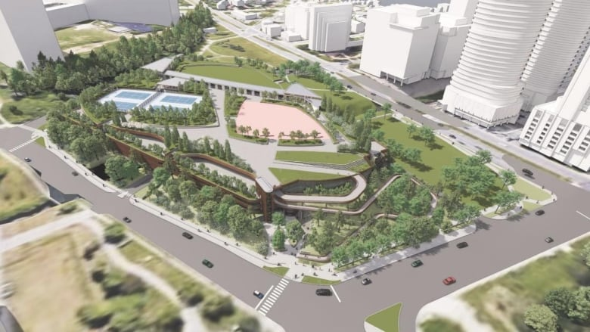

2. 1081 Carling Avenue - Proposal of two towers of 22 and 28 storeys
  - 1081 Carling Sub-Committee - Civic Hospital Neighbourhood Association (chnaottawa.ca)
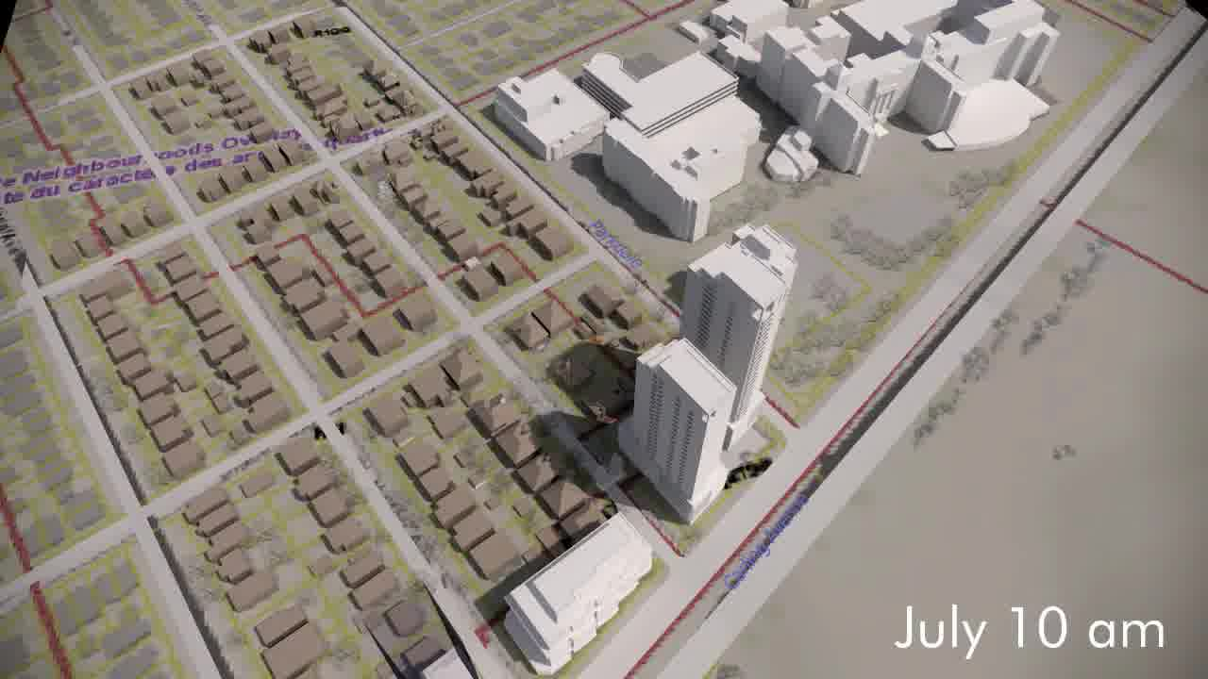

3. 30 Railway Street - Proposal of three storey, eight-unit low rise apartment dwelling
  - Planning and Development - Civic Hospital Neighbourhood Association (chnaottawa.ca)

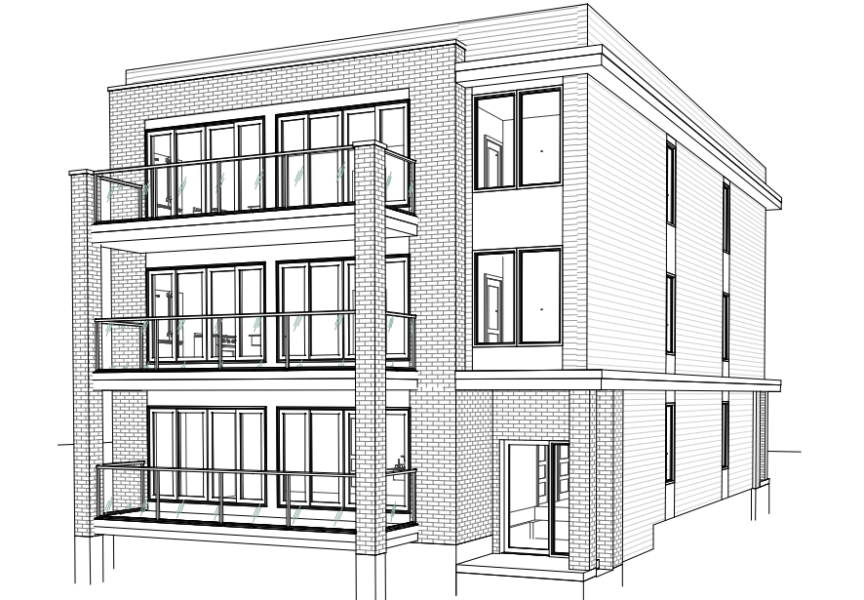

4. Rebuilding Hickory Street between Champagne Ave and the O-Train pedestrian bridge:

https://engage.ottawa.ca/hickory-street-row-re-instatement?fbclid=IwAR2R9YU3zqwj_ZA3ATBvirVKG_T87GmUU8OkOkdxTk_w2fLpGmJA6BgcRrA

Following is a link to the sketch concept:

https://engage.ottawa.ca/35640/widgets/147450/documents/100249

Overview of CHNA ACTIONS with Four Different Developments
Development | Positive Impacts | Negative Impacts and CHNA ACTIONS to Mitigate
1. The Ottawa Hospital New Civic Campus  - LOCATION: 930 Carling Avenue/520 Preston Street  - ESTIMATED COST: $2.8 billion development  -SCHEDULE: Ready by 2028  - STATUS:  First structure already approved by The City of Ottawa - Above ground four storey Parkade (February 2022) | - World Renowned Teaching Hospital specializing in trauma and Heart Institute  -Economic growth | - Threat to heritage designated sites - Central Experimental Farm, Queen Juliana Park –  CHNA ACTION: CHNA representation on The Ottawa Hospital New Civic Campus Advisory Committee to voice concerns on all potential negative impacts and propose solutions.  - Increase in Traffic -  CHNA ACTION: Include community in the study on Traffic  Impact of Reconstruction of Carling Avenue  New Civic Campus and Current Civic Campus plans for development/redevelopment, provide an opportunity to examine how Carling Avenue will be impacted. For instance, could the repurposed Civic Campus be entirely served from Carling Avenue?  Impact of other builds (towers) on Carling Avenue – 1053 Carling Avenue reconstruction adds to the mitigation challenges arising from 1081 Carling Avenue expansion, and the yet to be determined proposals for 991 Carling Avenue.  - Threat to mature trees -  CHNA ACTION:  - Accessibility given the nearly half-kilometre long connection between the current Carling O-Train station and the front doors of the future hospital. A "high-line" pathway would eventually cross the roof of the garage and arrive at the level of the hospital's doors –  CHNA ACTION:
2. Towers
- LOCATION:
1081 Carling
Proposal of two towers of 22 and 28 storeys
- ESTIMATED COST:
- SCHEDULE:
- STATUS:
3. Low Rise Apartment Dwelling
LOCATION:
30 Railway Street
Proposal of three storey, eight-unit low rise apartment dwelling
- ESTIMATED COST:
- SCHEDULE:
- STATUS:
4. Rebuilding Hickory Street between Champagne Ave and the O-Train pedestrian bridge | - Enjoyable public space and safe connection to O-Train.

ANNEX B
Impact of Surrounding Developments on Preston Street and Carling Avenue
45 Story Icon - Northeast corner of Preston Street; Up to 55 Floors, Three Tower Proposal – Northwest corner of Preston Street on former car dealership property
60 Storey Building – 829 Carling Avenue at Northwest corner of Preston Street, on CIBC Bank property Ottawa's tallest building will contain 459 units. The City's Planning Department has notified the public of City of Ottawa Official Plan amendment, zoning and site plan application to build this 60-storey tower. Federation of Citizens’ Associations of Ottawa (FCA) raises these questions to be addressed: How much parking do we need next to an LRT station? Are 6 storeys underground and 7 above ground enough? https://centretownbuzz.com/2021/11/skyline-another-preston-carling-tower-aims-high-is-it-a-reach-too-far/
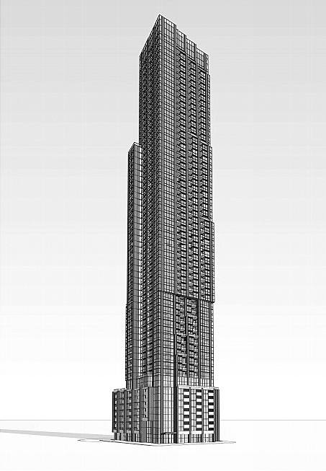

991 Carling Avenue
All_Image Referencing_Zoning Bylaw Amendment Application_Image Reference_D02-02-15-0077 Site Plan.PDF (ottawa.ca)
